ASR Correction with LLMs

- Error correction applied as post-processing step for ASR systems – requires only decoding hypotheses and reference data to train a model
- Early work – rule-based systems
  - Recent developments – e2e models with attention modules
  - PLMs – trained on massive datasets exceeding scale of data used in ASR training
  - Transfer knowledge from PLMs for accurate error detection and correction ie. ‘trnaformer based architecture’/’BART-based semantic correction system/masking strategy to train to correct original error tokens and predict masked tokens based on context information/etc.
- NLP – applied ChatGPT models for grammatical error correction tasks
  - Zero-shot performance using LLMs
  - Word confusion networks generated by ASR system and performed EC with ICL – improved performance with one-shot examples compared to 1-best hypotheses
- Novel approach using LLMs to improve ASR error correction
  - Comparing fine-tuning versus zero-shot error correction methods and investigating how ASR N-best lists can be effectively utilized
  - Using ASR N-best lists as extended inputs(?) which provides richer context and more accurate cues for error correction
  - Introduce advanced decoding strategies including constrained decoding to enhance model robustness and alignment with original utterance
  - Address data contamination concerns by developing methods to evaluate impact of training data biases
2. ASR error correction models
A. ASR Error Correction using N-best lists
- Utilising N-best ASR hypotheses generated by the ASR system as byproduct of beam search process
- Traditional ASR EC models allow model to generate any sequence based on given context – output space is not constrained
- N-best list – constrain model to generate limited space – N-best constrained decoding (constr) and N-best closest (closest).
B. Fine-tuning based Approach
- EC models aim to correct recognition errors in ASR transciptions for post-processing
- Require only decoded hypotheses
- Figure 1
  - ASR N-best lists given as input to encoder – model trained to generate manual reference
  - Sentences concatenated with special token [SEP]
  - Model trained to automatically detect errors and corrected hypothesis on specific training data
    - Supervised models – generalization capability crucial – enhance applicability across various scenarios
    - Experiments apply a model trained on transcriptions of corpus A generated by specific ASR system to out-of-domain test sets and outputs from other ASR systems
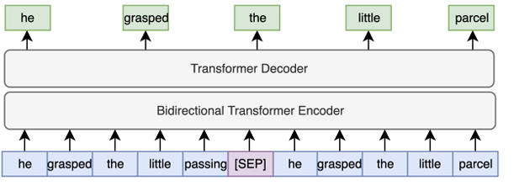
C. Zero-shot Approach
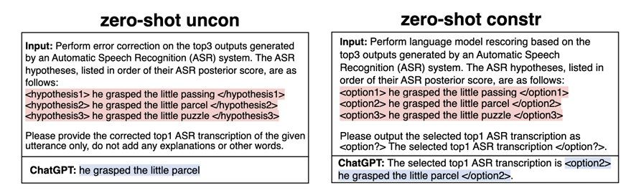
- Generative LLMs for zero-shot error correction – lacks prior knowledge about error patterns of ASR systems and no access to original utterance
  - Solution – provide hypotheses from N-best list as valuable hints
ASR Error Correction Decoding – method to direct model’s output in a more controlled and predictable manner
- Beam search – approximating optimal generation results across entire decoding space
  - Grants model too much freedom, limiting control over decoding process
  - Model expected to generate homophones for detected erroneous words
  - -> alaternative decoding algorithms to enhance ability to achieve desired decoding objectives
- N-best Constrained Decoding – want generated correction results to closely resemble original utterance
  - Constraints on decoding space involving leveraging ASR N-best list – top N hypotheses generated by ASR system
  - Transcriptions most likely to be correct given the input audio
  - Forces model to only generate sentences within ASR N-best list
  - Each path in N-best list associated with score calculated by ASR system, indicating likelihood of it being the correct output
    - Combining with scores from EC model and using interpolation weight to gain insights from both models
  - Zero shot EC scenarios – method applied differently
    - ChatGPT tasked with selecting most likely correct ASR transcription from list of candidates
    - Selection occurs in single step
    - LM sees all candidates before determining the best one – in contrast to rescoring process where LM scores are generated individually for each N-best hypotheses without considering similarity and correlation
C. N-best Closest Decoding
- Closest mapping method based on assumption that during unconstrained error correction, LLM choose best hypothesis from given N-best list and modify sentence to yield final output
- Identifying closest match by performing reverse process – locate hypothesis within ASR N-best list that has smallest Levenshtein distance to unconstrained generation result
- N-best closest approach does not constrain output space initially but finds closest match within N-best list after unconstrained generation
D. Lattice Constrained Decoding
- Expanding decoding space to include lattice generated through path merging
- Requires ASR decoding probabilities at each time step to generate lattice – needs access to ASR models -> only applicable in certain scenarios
Data Contamination
- Closed access to training data – challenges in determining if specific test data has been encountered during model’s pre-training phase
- Measure degree of data contamination problem on datasets utilized
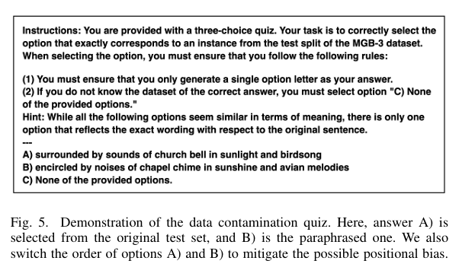
  - Use GPT4 to rewrite original manual reference
Experiments
- Datasets
  - LibriSpeech – audiobook-based English speech corpus
  - TED-LIUM3 – audio dataset collected from TED talks
  - Artie bias corpus
- ASR models
  - Conformer-Transducer model and OpenAI Whisper ASR
  - Evaluation – run text normalization scripts on both reference and hypothesis before calculating WER results following
- Fine-tuning ASR error correction Approach
  - Experimented with T5 base model
  - Build each EC model using same ASR training corpus with input transcriptions generated by corresponding trained ASR system
  - Results in WER improvements on the same set – N-best lists have potential in helping models recover correct transcription
  - Lattice constrained decoding results in slightly better performance
  - EC model tailored for Whisper adeptly detects and corrects errors for LibriSpeech corpus utterances in unconstrained decoding -> model effectively learned to correct errors in Whisper ASR from its training on LibriSpeech
    - Constrained decoding yields less improvements

T5's fine-tuning data = ASR-generated erroneous N-best transcriptions from SpecAugment-perturbed LibriSpeech training speech, paired with the original LibriSpeech reference transcripts.
For fine-tuning data generation for T5, might be simpler to have the Conformer read the augmented wav files instead using mel inversion – despite acknowledging that it introduces an additional lossy reconstruction step, if the objective is to create erroneous data for the Conformer, it might suffice.
Instead of

The paper “ASR Error Correction using Large Language Models” investigates whether pretrained/generative LLMs can improve Automatic Speech Recognition (ASR) transcripts after the ASR system has produced them. The central idea is that instead of modifying or retraining the ASR system, an external language model can act as a post-processing error corrector, which is particularly useful for black-box ASR services.
1. Core approach
The paper explores three main ideas:
- Give the correction model an N-best list rather than only the 1-best ASR output.
- Control how the LLM generates corrections using different decoding strategies.
- Test both supervised fine-tuning and zero-shot LLM correction, including whether a correction model can generalize across ASR systems and domains.
The overall intuition is important: the ASR's top hypothesis may contain an error, but another hypothesis in the N-best list may contain the correct word. Thus, the LLM gets several possible interpretations instead of having to infer everything from one potentially incorrect sentence.

2. Supervised approach: N-best T5
The first approach fine-tunes a T5-base model for error correction.
Instead of:
ASR 1-best → T5 → corrected transcript
the proposed system uses:
ASR N-best hypotheses → T5 → corrected transcript
The N hypotheses are sorted according to their ASR scores and concatenated using a special [SEP] token. T5 is trained to map these hypotheses to the human reference transcript.
The authors train this separately for:
- a Conformer-Transducer
- Whisper small.en
They use LibriSpeech for training and evaluate on LibriSpeech, TED-LIUM3 and the Artie Bias corpus.
Why N-best helps
The N-best list gives the model additional evidence. For example:
1-best: "the surgeon cut between these ligatches"
2-best: "the surgeon cut between these ligatures"
3-best: "the surgeon cut between these ligages"
The correct word may therefore already exist somewhere in the candidate list, making it easier for the correction model to recover it.

3. Decoding approaches
A major contribution is that the authors don't simply use standard unrestricted generation. They investigate several ways of controlling the correction output.
A. Unconstrained decoding
T5/LLM can generate any sequence.
This gives the model maximum flexibility, but it can also introduce unnecessary changes or generate text that is not close to the original ASR output.
B. N-best constrained decoding
The output is restricted to one of the original N-best hypotheses.
The model essentially has to select the best candidate while combining:
- ASR probability
- error-correction model probability
This is useful when preserving the original ASR content is important.
C. N-best closest decoding
This is an interesting compromise.
- Let the LLM generate freely.
- Compare the generated output against every N-best hypothesis.
- Select the hypothesis with the smallest Levenshtein distance to the generated output.
So the LLM has freedom during generation, but the final result is mapped back to an ASR candidate.
D. Lattice-constrained decoding
Rather than restricting the output to the N-best sentences, the authors use the ASR lattice, which contains many more possible paths.
This gives the model a larger search space than N-best decoding while still incorporating ASR probabilities. The disadvantage is that it requires access to the ASR decoding process and therefore isn't suitable for a completely black-box ASR API.
5. Main experimental results
The experiments show that N-best information is genuinely useful, but the effectiveness depends heavily on the ASR system and LLM.
Fine-tuned T5
For the Conformer-Transducer on LibriSpeech test-other:
System | WER
ASR baseline | 6.90
1-best T5 | 7.00
5-best T5 | 6.49
10-best T5 | 6.37
For Whisper:
System | WER
ASR baseline | 7.37
1-best T5 | 7.03
5-best T5 | 6.59
10-best T5 | 6.39
Thus, 1-best input is insufficient for the Transducer, whereas adding more hypotheses produces meaningful improvements. For Whisper, even 1-best correction helps, but N-best gives further gains.
The authors report particularly strong improvements for Whisper: the 10-best model reduces WER by 17.6% on test-clean and 13.3% on test-other.
7. Why does Whisper work less well?
This is one of the more interesting findings.
The authors analyse the diversity of the N-best lists.
For the Transducer, a 5-best list contains approximately 4.9–5 unique hypotheses.
For Whisper, it contains only around 2.6–3 unique hypotheses.
In other words, Whisper's "5-best" list often contains essentially the same transcription multiple times, differing only in punctuation, capitalization, or other formatting.
This matters because the whole proposed method depends on having alternative hypotheses containing useful information.
So:
N-best is useful only when the N-best hypotheses actually contain diverse alternatives.
This explains much of the difference between the Transducer and Whisper experiments.

8. Increasing N helps — but only up to a point
The authors also test different N values.
For GPT-3.5:
N | LibriSpeech | TED | Artie
1 | 8.25 | 11.95 | 21.19
3 | 7.01 | 11.31 | 18.84
5 | 6.64 | 11.35 | 18.73
10 | 6.69 | 11.29 | 18.72
The major improvement occurs when moving from 1-best to 3/5-best. Going from 5-best to 10-best provides little additional benefit.
So the conclusion isn't simply "more hypotheses = better." There is a trade-off between additional information and diminishing returns.

9. Generalization
A particularly important result is that the correction models can sometimes generalize beyond their training conditions.
For example, a T5 model trained using Transducer outputs on LibriSpeech was applied directly to:
- TED-LIUM
- Artie Bias
without additional fine-tuning.
The constrained approach achieved WERRs of 11.3% on TED and 10.3% on Artie.
The authors also test the harder scenario:
Train EC model on ASR system A → apply it to ASR system B.
An unconstrained model trained on Whisper struggled when applied to Transducer outputs. However, constrained decoding recovered improvements of 6.1% and 3.6% WER on LibriSpeech clean and other.
This suggests that constrained decoding can partially compensate for ASR-system mismatch.

10. Multi-ASR model ensembling
Another interesting experiment combines N-best lists from different ASR systems.
Instead of:
Transducer → LLM
or
Whisper → LLM
they give the LLM hypotheses from both systems.
The best combination produced:
GPT-4 WER = 4.72%
This was 32% lower than the Transducer baseline and 36% lower than the Whisper baseline.
They also combine two different Whisper models. GPT-4 obtains WERRs of 23% and 21% over the corresponding ASR baselines using the combined hypotheses.
Therefore, the LLM isn't merely being used as an error corrector—it can effectively act as an ensemble mechanism, integrating the complementary predictions of multiple ASR systems.

11. Data contamination
Because GPT-3.5/GPT-4 are closed models, the authors are concerned that the test transcripts might have appeared in their pretraining data.
They therefore create a contamination test:
- Take the actual test reference.
- Generate a paraphrase using GPT-4.
- Give the LLM the original and paraphrased versions.
- Ask it to identify which one came from the test set.
A high ability to identify the original could indicate memorization/data contamination.
The results suggest:
- GPT-3.5: little evidence of contamination.
- GPT-4: some evidence, particularly for LibriSpeech and TED-LIUM.
For example:
Dataset | GPT-3.5 | GPT-4
LibriSpeech | 0.07 | 0.33
TED-LIUM | 0.05 | 0.22
Artie | 0.14 | 0.15
MGB-3 | 0.04 | 0.02
Linguaskill | 0.03 | 0.09
The authors therefore acknowledge contamination as a concern, although they conclude that it does not invalidate the overall results.

Overall findings
The paper's main conclusions can be reduced to five points:
1. N-best information is much better than 1-best alone
Alternative ASR hypotheses give the correction model valuable clues about what the audio might actually have contained.
2. Fine-tuned T5 is effective
N-best T5 consistently improves ASR performance, especially when the N-best hypotheses contain diverse alternatives.
3. Zero-shot GPT-4 can be surprisingly strong
GPT-4 can outperform a specifically fine-tuned T5 system on Transducer outputs, despite receiving no ASR-specific training. Its average WERR reaches 25.2% on the three Transducer datasets.
4. The quality/diversity of the N-best list is crucial
Simply giving an LLM more hypotheses does not guarantee improvement. Whisper's repetitive N-best lists substantially limit the usefulness of the approach.
5. LLM-based EC can also function as model ensembling
Combining N-best outputs from multiple ASR systems gives the LLM complementary information and can produce substantial additional improvements.
The paper's central contribution in one sentence
The paper shows that LLM-based ASR error correction becomes substantially more effective when the LLM is given multiple plausible ASR hypotheses rather than a single transcript, while appropriate decoding constraints can control hallucinated corrections and allow the method to generalize across ASR systems and domains.
A particularly interesting takeaway for discussion is that the bottleneck may not actually be the LLM—it can be the quality and diversity of the information supplied by the ASR N-best list.

